**Configuration menu**

**Introduction**

Configuration menu is a menu through which user can configure settings of the device “Sniffer RS-232”. The menu starts if user presses any key at start of the firmware within certain time window (see pic. 1)

Each menu item can be entry to submenu or be end item with value which should be typed by user. If menu item has value, it is displayed in ‘[]’ after name of menu item. In case if menu item has enumerated value, it also is menu entry to submenu where user can choose certain value from the list based of menu items of submenu. User can enter to submenu by pressing ENTER button and navigate over menu items by pressing UP and DOWN buttons. If menu item has not enumerated value user see prompt (with value range if exist) below menu where value should be typed. If typed value is out of its range content of appropriate menu item is not changed.

Pic. 1

**Main menu**

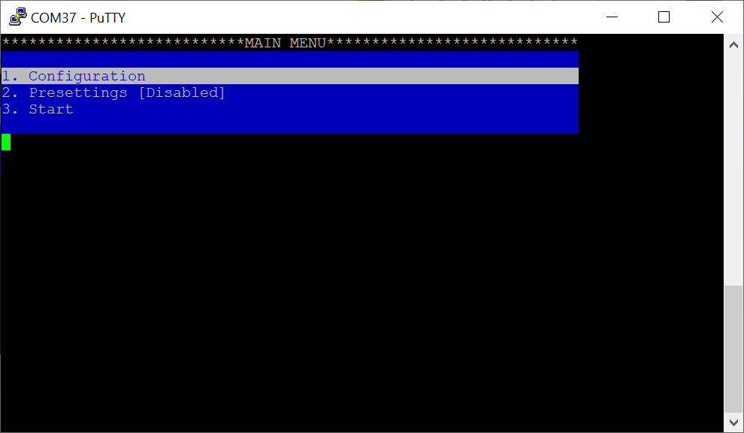

Pic. 2

Configuration menu starts at top level called “Main menu”. “Main menu” consists of the following items:

1. Configuration – main menu of configuration related to algorithm settings and display of monitored data
2. Presettings – presettings of UART parameters set directly by user. If enabled (shown by value of the menu item), algorithm is not used, and the device starts data monitoring immediately
3. Start – exit from menu and start device working (see part **Menu exit**)

**Configuration**

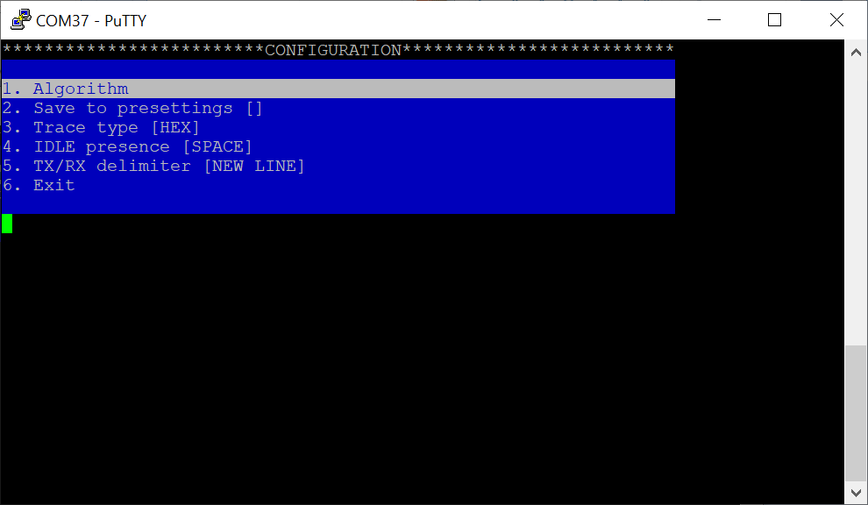

Pic. 3

Menu “Configuration” consists of the following items:

1. Algorithm – settings of the algorithm used for recognizing UART parameters of monitored RS-232 lines
2. Save to presettings - mark if successfully recognized UART parameters by the algorithm should be placed into values of menu “Presettings” and enables it for next start of the device
3. Trace type – type of display of monitored data. If chosen ‘HEX’, data is displayed in hexadecimal format with bright color started with letter ‘\’ (for example ‘\1F’ or ‘\1AC’). If chosen ‘HEX/ASCII’, data is displayed in hybrid format: if data is printable ASCII symbol it’s displayed as this symbol with normal color if not it’s displayed in hexadecimal format as it was explained above.
4. IDLE presence – letter presence of IDLE state on RS-232 line. If chosen ‘NONE’, nothing displayed if IDLE detection occurred. If chosen ‘NEW LINE’, next data after IDLE detection will be displayed on next line. If chosen ‘SPACE’, space letter is put before next data
5. TX/RX delimiter – letter separating data from different lines of RS-232 (TX & RX). If chosen ‘NONE’, nothing displayed to separate data. If chosen ‘NEW LINE’, RX data after TX one (and vice versa) will start on next line. If chosen ‘SPACE’, space letter is put between TX & RX data
6. Exit – exit to upper menu

**Algorithm**

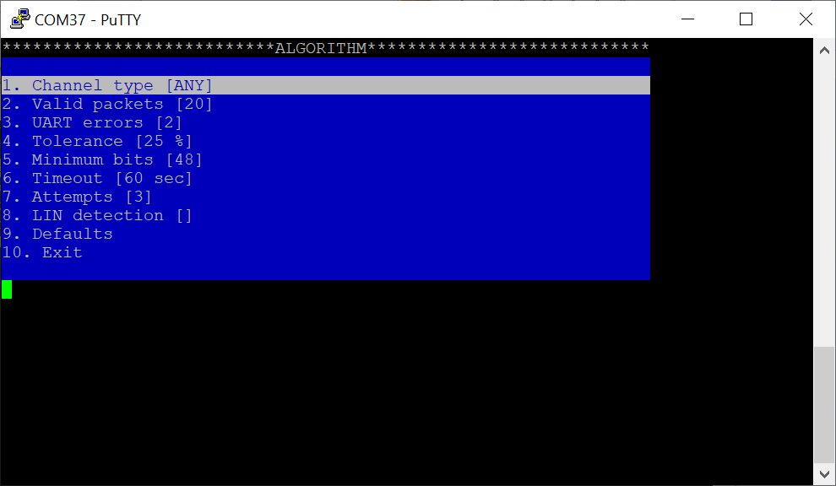

Pic. 4

Menu “Algorithm” consists of the following items:

1. Channel type – which lines of RS-232 should be monitored during the algorithm. If chosen ‘ANY,’ the algorithm stops after successful recognizing of UART parameters on one of the lines. If chosen ‘TX’, only data on TX line is monitored. If chosen ‘RX’, only data on RX line is monitored. If chosen ‘ALL’, algorithm is successful only if parameters on both lines are recognized.

**Note.** Despite of channel type if algorithm is successful recognized parameters are applied to both lines

1. Valid packets – count of valid packets (8-bit or 9-bit data) should be received to consider that UART parameters are valid
2. UART errors – count of errors which should occurred to consider that UART parameters are not valid
3. Tolerance – baud rate tolerance in percentage, used in baud rate calculation
4. Minimum bits – how many bits should be read to calculate baud rate successfully. The more this value the more probability of correct baud rate calculation but time of the algorithm work is also more
5. Timeout – maximal time of algorithm work
6. Attempts – how many times algorithm (re-)starts until it’s successful
7. LIN detection – mark if the algorithm should also detect LIN break. In case if LIN break is detected and baud rate is calculated the algorithm does not perform calculation of other UART parameters but uses parameters 8N1 as only applicable for LIN line
8. Defaults – reset algorithm settings to default values
9. Exit – exit to upper menu

**Presettings**

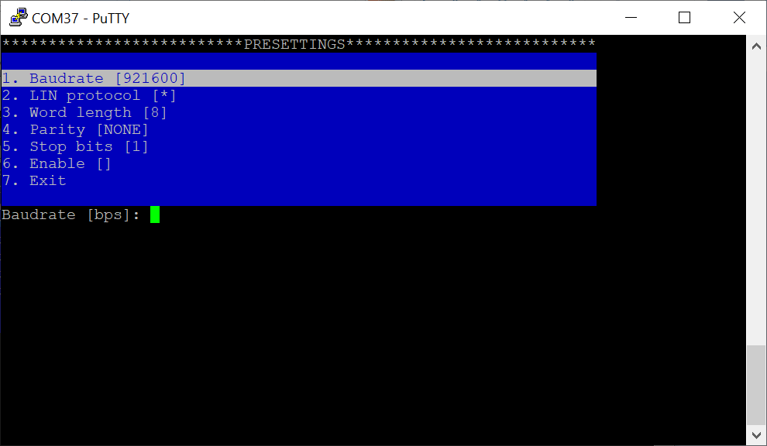

Pic. 5

Menu “Presettings” consists of the following items:

1. Baudrate – baud rate of UART in bps
2. LIN protocol – mark if LIN protocol implemented on UART line. if marked, menu items “Word length”, “Parity” and “Stop bits” are forced to values “8”, “NONE” and “1” respectively and cannot be changed until LIN protocol is unmarked
3. Word length – length of UART frame, available 8 or 9 bits
4. Parity – type of parity bit, available even, odd or no parity bit
5. Stop bits – count of stop bits, available 1 or 2 stop bits
6. Enable – mark whether pressetings are applicable to RS-232 lines and the algorithm does not start and the device starts monitoring immediately after exit configuration menu. Value of this menu item is also displayed in menu item “Presettings” in “Main menu”
7. Exit – exit to upper menu

**Menu exit**

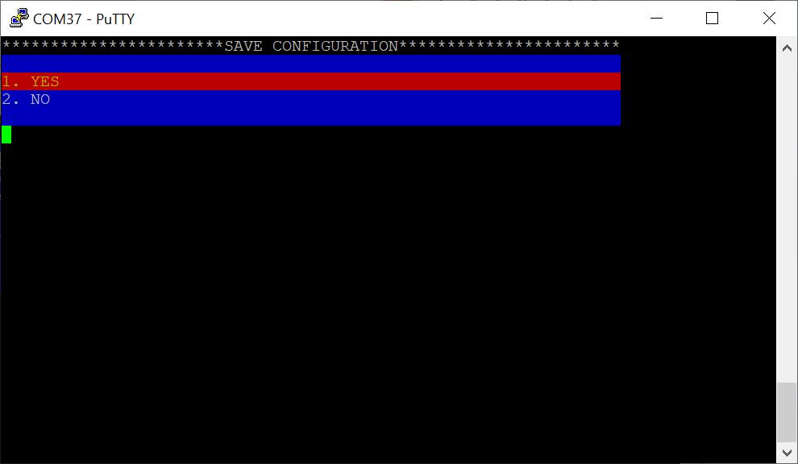

Pic. 6

In case if some parameters were changed during work with menu by exit from “Main menu” dialog “Save configuration” is open. If variant “YES” is selected changed settings will be applied and stored into non-volatile memory of the device. If variant “NO” is selected settings will not be applied and previous values are remained. Choosing of any variant exits from configuration menu.

In case if parameters were not changed configuration menu exit is performed without dialog “Save configuration”.